Sample Social Media Posts – #PlanToRenew
To ensure newly-insured people are able to stay covered and receive the financial help they are eligible for, we have created social media content encouraging consumers to Plan to Renew. If you have any questions or feedback, please contact Christine Lindberg (clindberg@communitycatalyst.org)
Did you buy a new health plan last year? You may be eligible for new or different financial help this year. Know your options. #PlanToRenew
Staying covered is as easy as 1, 2, 3! #PlanToRenew by December 15(ADD GRAPHIC)
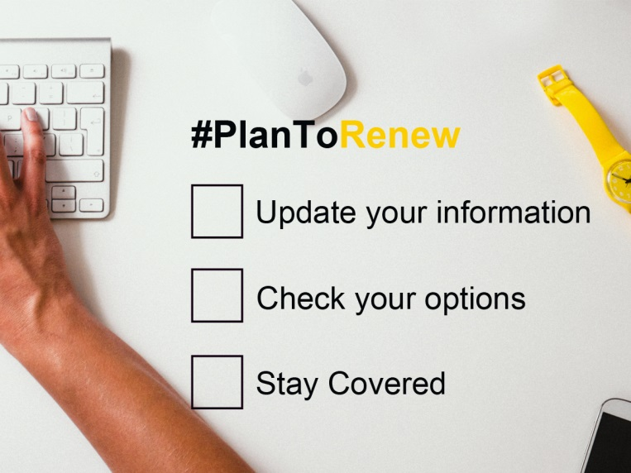 (Download image here)
If you bought health insurance on the Marketplace, it can pay off to check out your options before renewing coverage #PlanToRenew by 12/15
Listen to your Navigator. Open enrollment starts on 11/15 and it’s time to shop around. #PlanToRenew [ADD GRAPHIC]
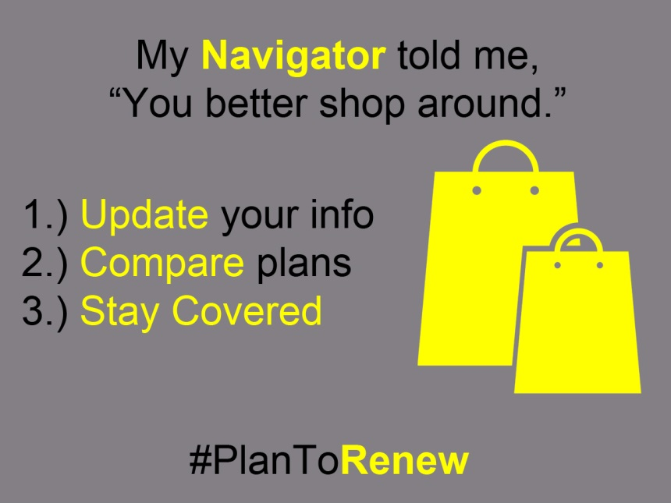 (Download image here)
Have questions about how to #StayCovered? One-on-one help is available. Find a Navigator near you and #PlanToRenew [Add link to local help site]
Renewing your plan will give you & your family peace of mind in 2015 AND you could save even more on your plan this year #PlanToRenew

