“Filing a Consumer Health Insurance Complaint”
Infographic (resizeable .png image file)

From:
Consumer Complaints Toolkit: Health Insurance Resources for Health Advocates, Health Providers and Enrollment Assisters
http://www.communitycatalyst.org/resources/tools/consumer-complaints-toolkit

INSTRUCTIONS: To copy this infographic for use in electronic or print materials, click on it and copy/paste the image file into documents or social media platforms. As a .png image, it can be saved, resized and used in the same ways as a .jpg photo image.

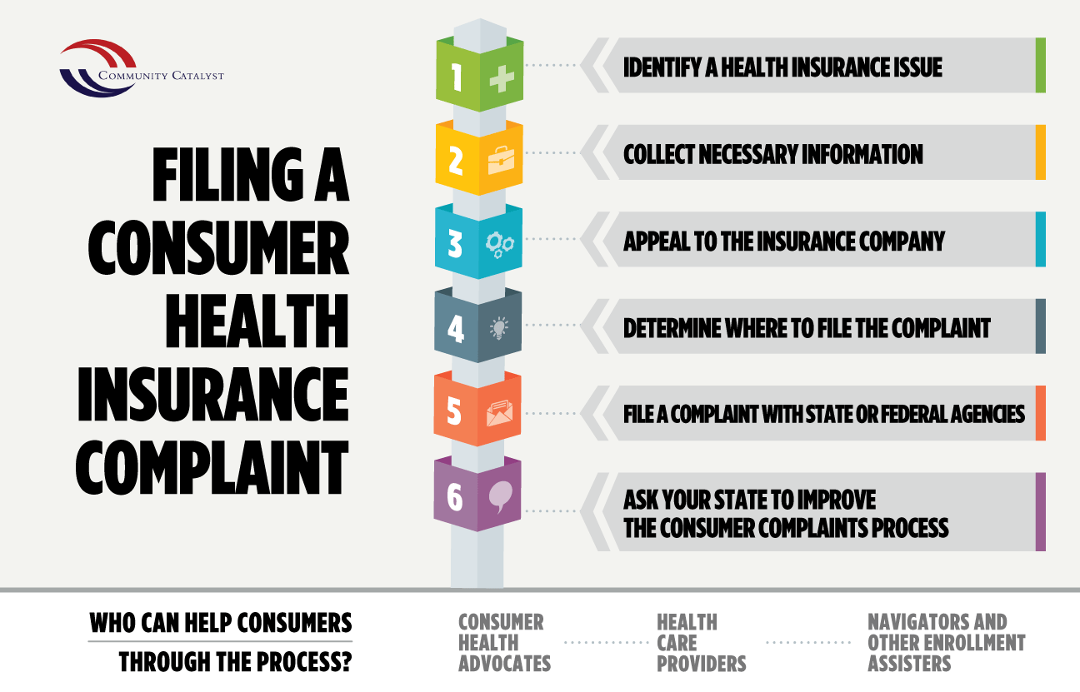

Community Catalyst copyright 2016

